**INTERNAL DIRECTIVES AND POLICIES**

**TOXIKON PROTOCOL MANAGER USER GUIDE**

Reference Number: IDP 20.4.1

Revision Number: 000

Toxikon Corporation

Bedford, MA 01730

1. Description:

Toxikon Protocol Manager (TPM) is a windows application managing protocol requests from clients. It allows Sales / Customer Service to submit protocol requests and Doc Control to manage the protocol requests that are assigned to them.

This document includes all features that are available to Doc Control users.

1. Installation:

Please contact IT department for more information.

1. Menu:

When you are logged in as a Doc Control user, your main application menu will appear as below:

C:\Users\BMcCulley\Documents\ToxX Documentations\DocControl\Menu.PNG

1. Home Tab:

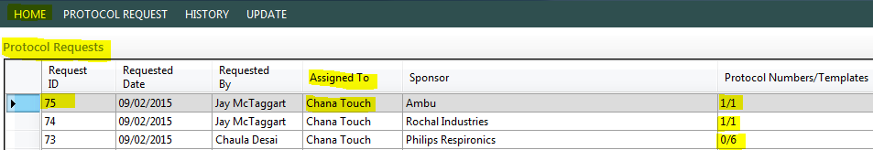

On the home page, you will see a list of protocol requests submitted by Sales / Customer Service.

**Request ID**: this is a sequence number that is automatically increased when a new request comes.

**Requested Date**: the date when the request is submitted.

**Requested By**: the person who submits the request.

**Assigned To**: Doc Control user.

**Sponsor**: the protocol request’s sponsor name.

**Protocol Numbers/Templates**: this column shows you how many templates are requested in this request and how many are already assigned with a protocol number.

*For example for request ID 73 in the image above, it shows that there are 6 templates in this request and 0 protocol numbers assigned.*

1. Protocol Request Details Page:

To get to protocol request details page, double click on the request on the Home page.

* 1. **Menu Bar:**

C:\Users\BMcCulley\Documents\ToxX Documentations\DocControl\RequestDetailsMenuBar.PNG

* + 1. *Protocol Request:*

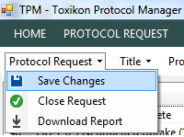

**Save Changes**: saves ONLY the changes you made in **Protocol Request** **Information** (5.3).

**Close Request**: only use this button if the request is finished which means all the protocols in the requests are FINAL and you want to move this request into the **History** list. When an item is moved to the **History** list, it will become READONLY.

**Download Report**: creates an excel file that contains all the information, events and comments in this request. The report will have several sheets: Protocol Request sheet; Protocol 1, 2, 3… as below

C:\Users\BMcCulley\Documents\ToxX Documentations\DocControl\ExcelSheetNames.PNG

* + 1. *Title:*

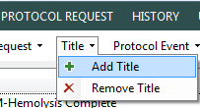

**Add Title**: allows you to add additional protocol template into the request.

**Remove Title**: this is usually used when the client cancels one of the templates that they requested. There will be a confirmation dialog pop up to make sure you want to continue with the action.

* + 1. *Protocol Event:*

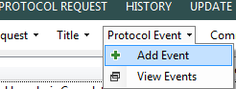

**Add Event**: there are many steps in between the submission of a protocol and its completion. So with this button, **Add Event** allows you to insert the step you’ve done into **Events** log. This helps other users keep track of their request status. Events example: Put Up Protocol, Sent Out Protocol, Sent Protocol To QA…

**View Events**: shows all the events you inserted using the **Add Event** button:

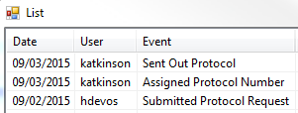

* + 1. *Comments:*

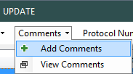

**Add Comments**: add comments to a specific template.

**View Comments**: shows all the comments you entered using **Add Comments** button.

* + 1. *Protocol Number:*

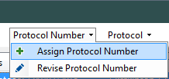

**Assign Protocol Number**: creates a new Protocol Number automatically and assigns it to a specific protocol template.

**Revise Protocol Number**: a new protocol number will look like this “P15-1453-00A” where “00” is the original document, but if the protocol is revised then the protocol number also needs to be revised to “01”, “02”, “03”, and so on. So when you click this button, it will do that step for you and update the protocol number to something like “P15-1453-01A”.

* + 1. *Protocol:*

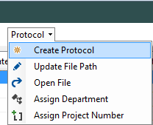

**Create Protocol**: copies the original protocol document with bookmarks to the location you select, fills the document with information such as Protocol Number, Sponsor Name, Address, and saves it as ProtocolNumber.docx

**Update File Path**: updates the location of the protocol document.

**Open File**: opens the protocol document if the location is valid. If the file is word document then it will be opened in Word, if it’s PDF file it will be opened in Adobe Reader or Acrobat.

**Assign Department**: assigns a department that is in charged for the selected protocol.

**Assign Project Number**: if you know the associate Project Number of a protocol, you can insert it into the system using this button.

* 1. **Titles List:**

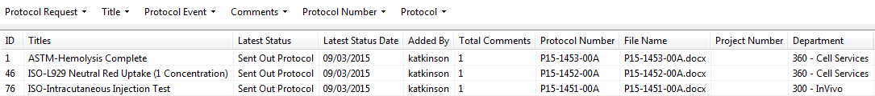

This list contains all the templates that are requested. To update template information using the tools in the menu bar, simply click on a template and select the tools as described in 5.1.

* 1. **Protocol Request Information:**

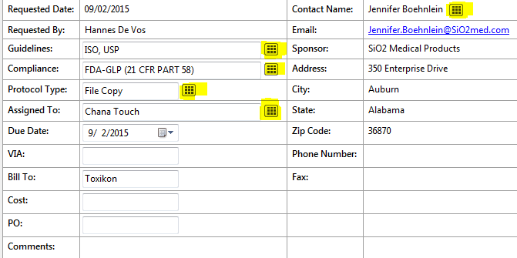

This is the form that Sales / Customer Service fills in when they submit a request. If you want to make changes on selection fields, click on the highlighted buttons as shown above. For text fields, you can click on the text box and start typing. After you make the changes, make sure to go to the menu bar, select **Protocol Request** -> **Save Changes**:



1. Protocol Request Tab:

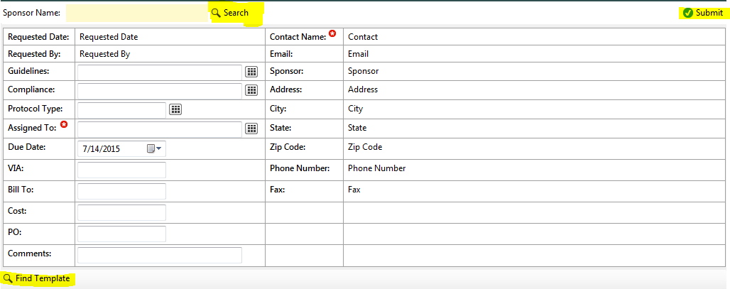

To submit a protocol request, click on **Protocol Request** button on the menu bar. It will show you the request form as above.

Step 1: type in sponsor name that you want to submit the request for.

Step 2: click **Search** button. It will show you the list of contacts for this sponsor. NOTE: new sponsor has to be registered in LIMS first and has to have at least ONE contact to be able to submit the request.

Step 3: select a contact name and click submit button in the form below:

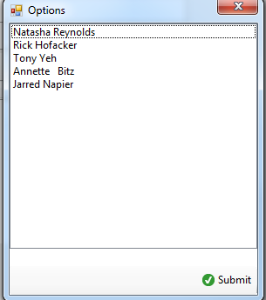

Step 4: fill in the rest of the form.

Step 5: add protocol templates into the request using **Find Template** button:

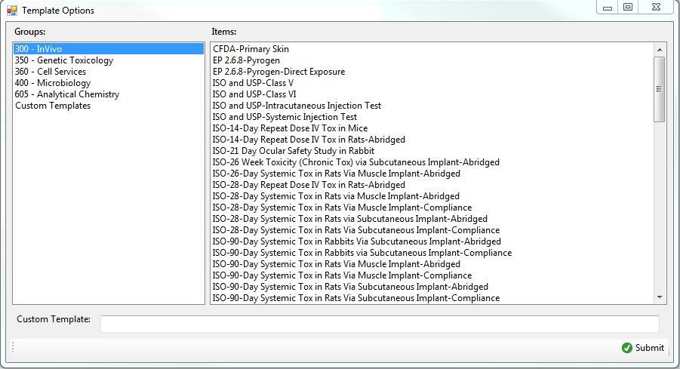

Protocol templates are grouped by department. Click on the department name, you’ll see all the exist templates for this department. Select the template you want and click **Submit** button.

If the template is client specific, you can type in the template name in **Custom Template** text field.

Step 6: Click **Submit** button on the corner right of the form to submit the request.

1. History Tab

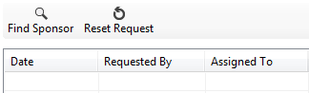

On this page, it allows you to look up a closed request. It also allows you to reset a request if you accidentally close the request before it’s finished.

**Find Sponsor**: shows a popup list of all sponsor names have been submitted to the system. Select the sponsor name to see all the requests come from this sponsor.

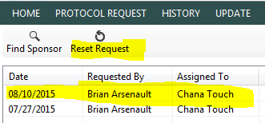

**Reset Request**: select the request you want to request and click **Reset Request** button. This will bring the request back to protocol request list on Home page.

1. Update Tab

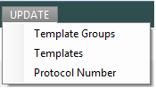

As mentioned before, protocol templates are group into departments.



So if you have a new department needs to be added into **Template Options** popup windows, you can click on **Update** -> **Template Groups**. On this page, it has options for you to create new group (department name in this case), or update the existing group.

**Update** -> **Templates**: allows you to add new template into a group. For example if department 300 – InVivo has a new protocol template created and you want to add it into the selection, you can click on **Update** -> **Templates**, select the group you want to add the template in, type in the new template name and then click **Add** button.

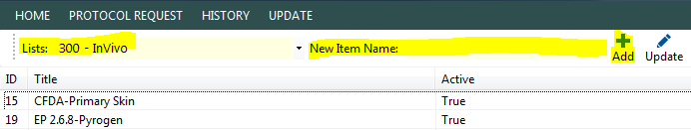

To update the name of a template, select the template name and click the **Update** button (next to the Add+ button). From there, you can edit the template name, modify the group ID, or make the template active or inactive.

1. TPM Web Overview

The Protocol Manager also has a read-and-search-only web version available for concurrent or independent use with the Windows application TPM. No creating or editing is possible from this view.

* 1. Protocol Requests Tab

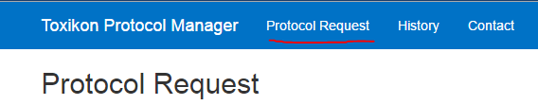

When you first navigate the TPM Web application at <http://toxx.toxikon.com/tpmweb> , you will be brought to the Protocol Request View, which displays all active Protocol Requests in the TPM.

The requests will be ordered by protocol number in a table. Below, the columns are explained:



**Request ID**: The sequence Number automatically assigned to a new Protocol Request.

**Requested Date**: The date when a request is submitted.

**Requested By**: the person who submits the request.

**Assigned To**: Doc Control user.

**Sponsor**: the protocol request’s sponsor name.

**Guidelines:** Lists the required guidelines to follow for the protocol (FDA, ISO, etc.)

**Compliance:**Designates the compliance regulations to follow for the protocol (GMP, Non-GLP, etc.)

**Protocol Type:** File Copy vs. Single Copy

To sort any of the columns, simply click on the table headers to toggle ascending or descending sorting for that column. Column sorting is a stable sort, meaning that original order will be preserved in the case of a tie. For example, if you want to see protocol requests ordered first by the **Requested By** column then sorted within each requester by the sponsor who requested it, then you would sort first click the **Sponsor** header, then click the **Requested By** header.

* 1. History Request Tab

This page displays all closed Protocol Requests, allowing for searching and filtering to find any protocol requests that need to be reset from the TPM Windows App.

* 1. Search

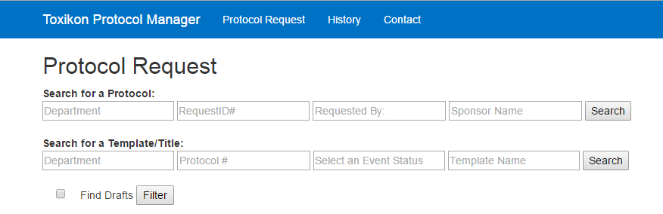

The search abilities allow for the Web TPM to greatly complement the Windows app. All search fields within the same line (i.e. Department and Sponsor Name) are stackable, so they may both be applied to a search.

Many of the search fields contain a dropdown menu of possible search criteria. For example, when searching by **Department**, you can click into the text box and (depending on your browser) will either get autocomplete options for what you’ve already typed or a drop-down list of possible inputs.

To search for an entire protocol request, use the first row of search fields and its **Search** button. This will return a view similar to the home protocol request list, with the results filtered based on your search criteria.

To search for specific templates within all of the requests that are both active and closed, use the second row of search fields and its **Search** button. This will take you to a similar list view that contains protocol templates with some info from the request that contains them.

Lastly, if you wish to search for all templates that are still in a draft phase, check the box next to **Find Drafts** and click **Filter**.